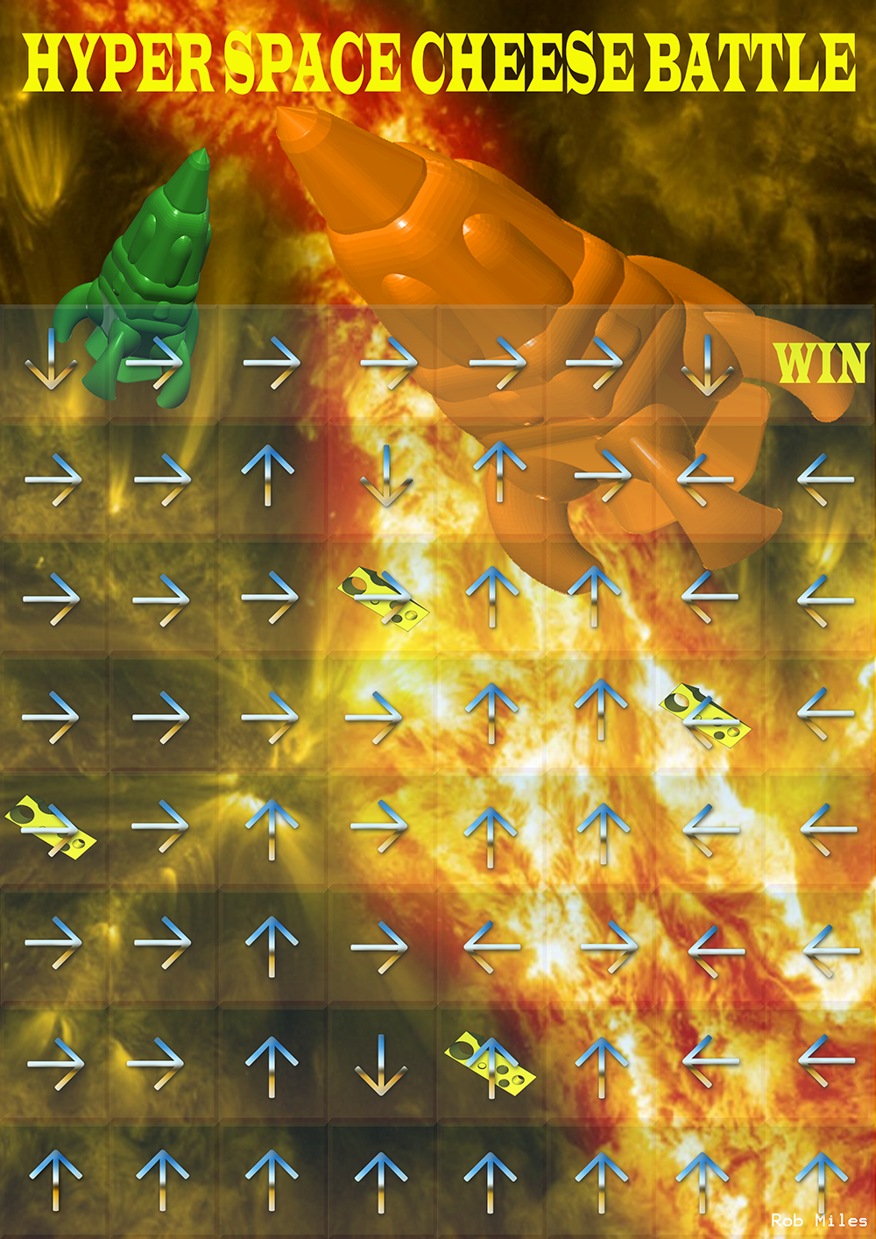HyperSpace Cheese Battle User Manual

Contents:

1. Title page
2. Contents
3. How to play

6) Testing mode

How To Play

Follow this simple step-by-step guide on how to run and play HyperSpace Cheese Battle:

1. Run the HyperSpace Cheese Battle.exe
2. You should be greeted with the main menu screen. Here you will be asked whether you want to run testing mode (more on page 4), type ‘n’ and press enter.
3. 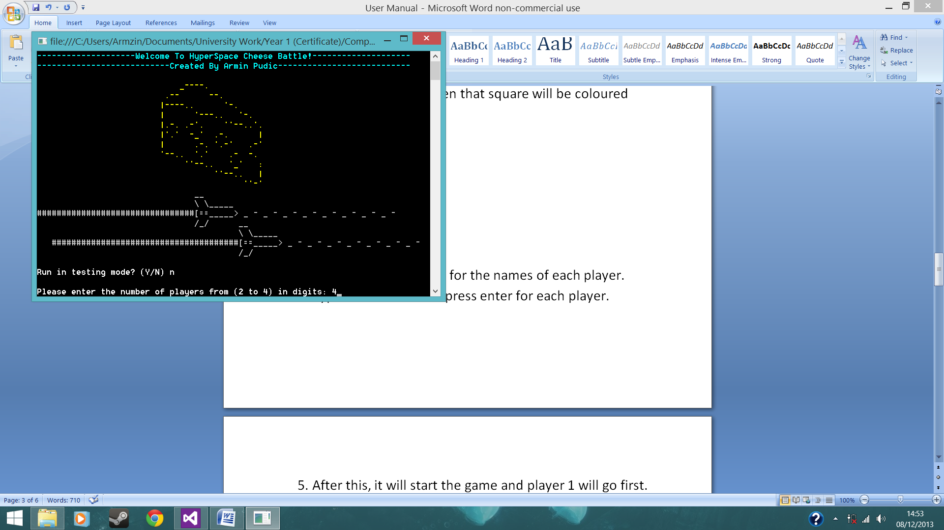You will be asked how many players will play. Type in the number of players and press enter (2-4 players only). Each player will have their own colour and the squares on the game board will be coloured with the colour of the player that is on that square (e.g. If player 1 is on square (3,4) then that square will be coloured blue)  
   Player 1 = Blue  
   Player 2 = Red  
   Player 3 = Yellow  
   Player 4 = Green

1. You will then be asked for the names of each player. Type in the name and press enter for each player.
2. After this, it will start the game and player 1 will go first. The aim of the game is to get to the win zone (7,7). To do this you roll the dice each turn (by pressing enter) and your rocket will move in the direction that the arrow you are on is facing. For example, if you are on an arrow facing right and you roll a 3 then you will move 3 spaces to the right.
3. If you roll a six then you activate the ‘six power’ and get to roll again!
4. 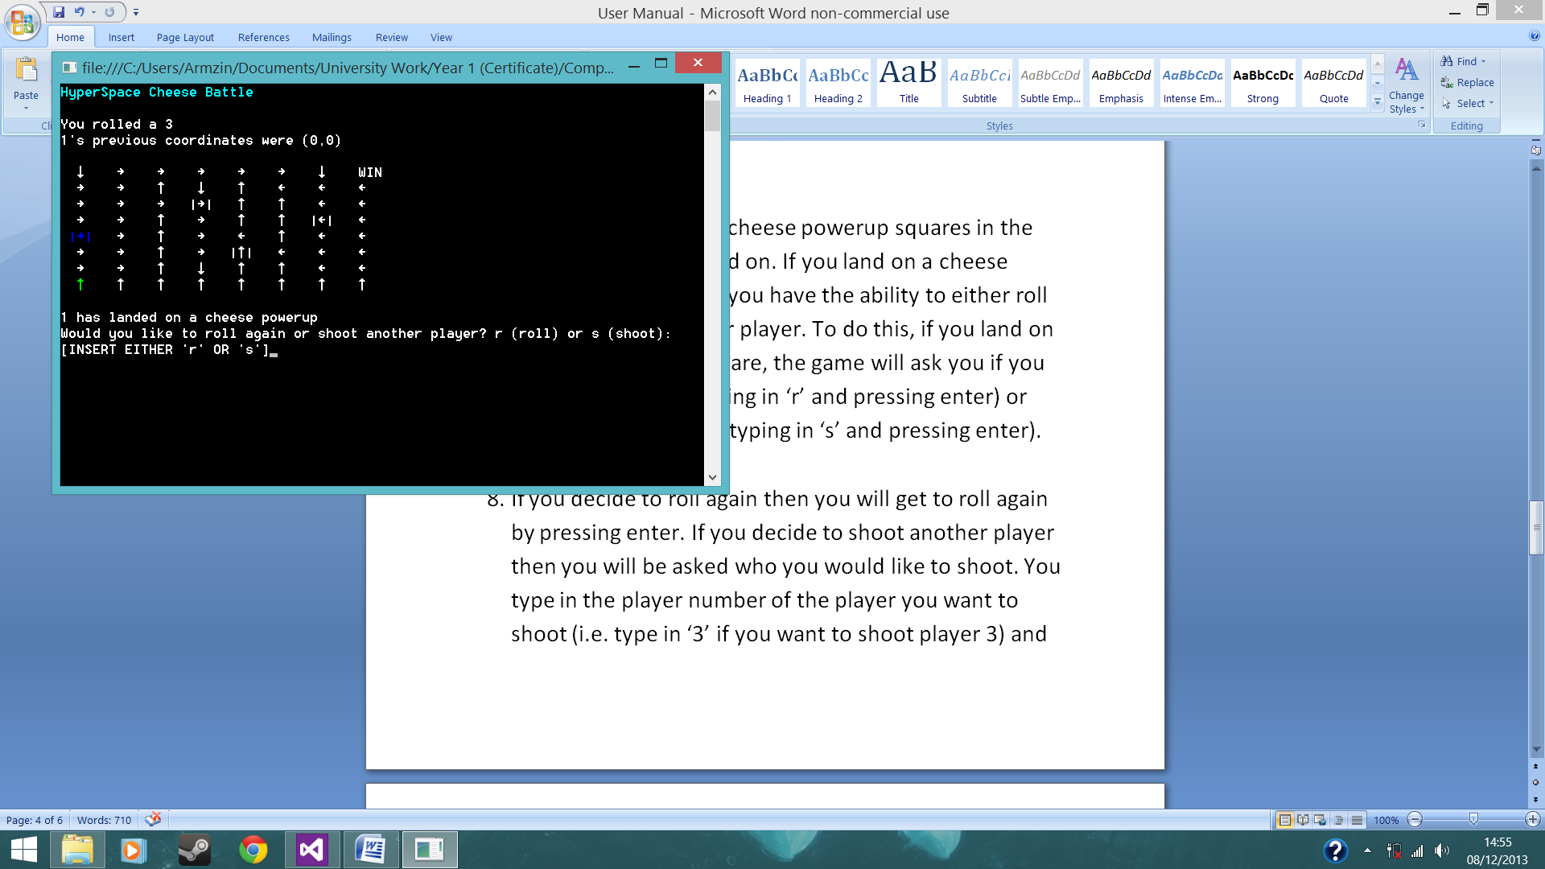There are also special cheese powerup squares in the game that you can land on. If you land on a cheese powerup square then you have the ability to either roll again or shoot another player. To do this, if you land on a cheese powerup square, the game will ask you if you want to roll again (typing in ‘r’ and pressing enter) or shoot another player (typing in ‘s’ and pressing enter).

1. If you decide to roll again then you will get to roll again by pressing enter. If you decide to shoot another player then you will be asked who you would like to shoot. You type in the player number of the player you want to shoot (i.e. type in ‘3’ if you want to shoot player 3) and press enter. You cannot shoot yourself and you cannot shoot a non-existent player. Shooting a player will cause that player to crash land and changing their Y coordinate to 0. The player you shot will be asked which X coordinate they want to crash land on (i.e. Type in ‘6’ if you want to crash land on the (6,0) square). You cannot type in a non-existent X coordinate. Once the player has crash landed then your turn is up. When it is the player that was shot’s turn, that player will start their turn on their crash landed square.
2. If a player goes over the board then they are teleported back to their original position. If you collide with another player (you land on the same square as another player) then you will bounce off of the other player and move 1 square in the direction that the player you collided with square was facing.
3. After someone wins, you will have the option to play again. When the game asks you if you want to play again then type in ‘y’ and press enter to play again or ‘n’ and press enter to exit the game.

Testing Mode

Testing mode is used to test the game and shouldn’t be used if you just want to play the game. Testing mode allows you to enter a value for the dice throw so you can move the players to the positions you want.  
  
To activate testing mode simply type in ‘y’ and press enter when it asks you if you want to run in Testing Mode at the beginning of the game.